Question 13:
Create a dictionary of five meal items and their calories. Add one more item and print the dictionary.
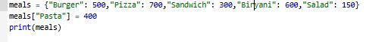
Output:

